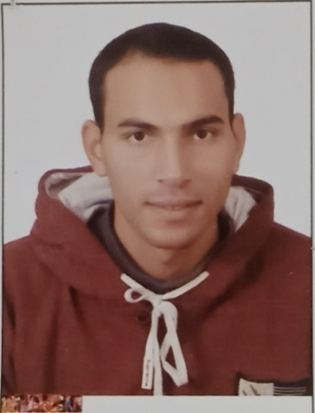
Curriculum Vitae
Name: Mohamed Sayed Ahmed
Date of Birth: May 4th,1994
Gender: Male
Religion: Muslim
Nationality: Egyptian
Home Address: Assiut, Egypt
Contact Address: Department of Pharmaceutics, Faculty of Pharmacy, Assiut University
E-mail: mohmdsayed49@gmail.com
Mohamed.S.Ahmed@pharm.aun.edu.eg
Phone Number: 01141980672
Languages: English (professional), Arabic (native language).
Academic Qualifications:
Bachelor in Pharmacy, Faculty of Pharmacy, Assiut University in 2018, and Demonstrator at Pharmaceutics Department, Faculty of Pharmacy, Assiut University.
Excellence with honor
Grade:
Demonstrator at Pharmaceutics Department Faculty of Pharmacy, Assiut University.
Computer Skills:
1- Microsoft Office Word.
2- PowerPoint.

